2D Platforming Research

Introduction

When looking to the likes of 2D Platformers, you will often find that they are all similar down to the bone. The genre is very simple, yet one that continues to challenge gamers with each new addition to the genre. My main objective to observe and critique the subject of “challenge”, as well as their design. I’ll be looking at *(Matt Makes Games, 2018) Celeste*, *(Team Meat, 2010) Super Meat Boy,* and lastly *(Bennett Foddy, 2017) Getting Over It with Bennett Foddy*.



**Celeste**

Celeste is a very straightforward kind of platform that has you utilise a set of simple, yet hard to master mechanics. One of these mechanics is the “mid-air dash” which can be seen in Fig 1. Celeste is a very fast paced kind of platformer that throws the player into a progressively more and more difficult set of stages. One of the main obstacles the player will need to deal with are spikes, which are a very common type of *Fig 1. Mid Air Dash mechanic.*

Hazard that goes back to the days of Mario. The main challenge here is getting use to the very perfect-timing style of platforming.

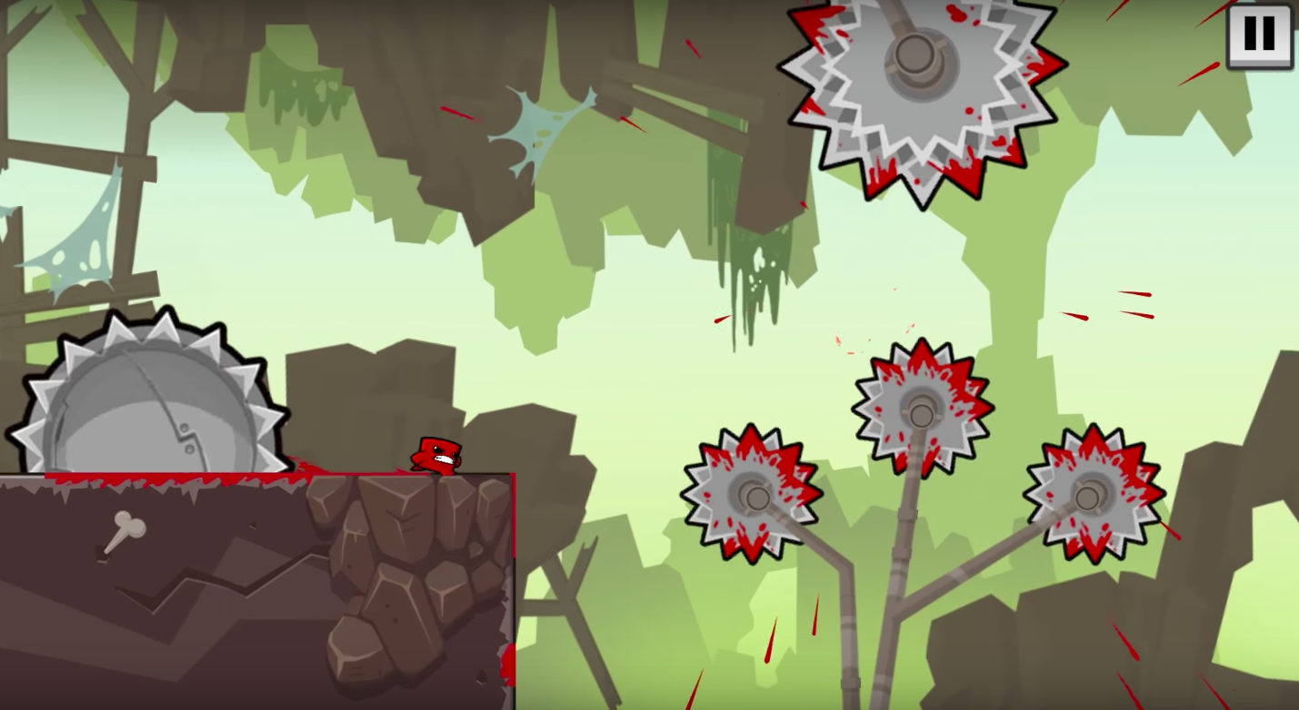

**Super Meat Boy**

Super Meat Boy is a very swift kind of platformer that punishes the player very little due to the nature of the game. The player has very little respawn delay, and therefore can restart the level multiple times over. There are over 200 different level designs, all with very similar gameplay. The main point to takeaway is that this game doesn’t have a traditional “gameover” type of system that other games do, as its sole intention is to encourage the players to keep playing a level, then another, then another. The main challenge here is cushioned by the fact the player can respawn very quickly.

**Getting Over It with Bennett Foddy**

Getting Over It is a much different kind of platformer, as from the get go the controls of the game is extremely awkward. It is mainly controlled by using Mouse, and circular movements of the mouse. It requires the player to think carefully about the speed and position of their mouse when trying to move their character. However, it is very easy to spend 40 minutes progressing through the level, and with a single accident you’re back at the very beginning of the game. The way the creator goes about trying to cushion the player is by having encouraging, and inspiring voice clips with the intention of telling the player that they will, in essence “get over it” and progress if they try. The challenge, therefore, is very apparent to the player from the get go, and Bennett Foddy tries to encourage the player when they mess up.

Game bibliography:

*Humble Bundle. Bennett Foddy. 2017. Getting Over It with Bennett Foddy. Game Page:* [*http://www.foddy.net/2017/09/getting-over-it/*](http://www.foddy.net/2017/09/getting-over-it/) *Last Accessed: 03/02/2019.*

*Matt Makes Games. 2018. Celeste. Game Page:* [*https://store.steampowered.com/app/504230/Celeste/*](https://store.steampowered.com/app/504230/Celeste/) *Last Accessed: 03/02/2019.*

*Team Meat. 2010. Super Meat Boy. Game Page:* [*https://store.steampowered.com/app/40800/Super_Meat_Boy/*](https://store.steampowered.com/app/40800/Super_Meat_Boy/) *Last Accessed: 03/02/2019.*